Ashton Ishmael Museredza
25/SCA/BCDS/023

1.ARRAY OPERATIONS
#include <stdio.h>
int main() {
int arr[10], n, choice, pos, value, i;

printf("Enter number of elements: ");
scanf("%d", &n);

printf("Enter elements of the array:\n");
for(i = 0; i < n; i++) {
scanf("%d", &arr[i]);
}

while(1) {
printf("\nMenu");
printf("\n1. Insertion");
printf("\n2. Deletion");
printf("\n3. Display");
printf("\n4. Exit");
printf("\nEnter your choice: ");
scanf("%d", &choice);

switch(choice) {
case 1:
printf("Enter position to insert: ");
scanf("%d", &pos);
printf("Enter value to insert: ");
scanf("%d", &value);

for(i = n; i >= pos; i--) {
arr[i] = arr[i - 1];
}
arr[pos - 1] = value;
n++;
printf("Element inserted successfully.\n");
break;

case 2:
printf("Enter position to delete: ");
scanf("%d", &pos);

for(i = pos - 1; i < n - 1; i++) {
arr[i] = arr[i + 1];
}
n--;
printf("Element deleted successfully.\n");
break;

case 3:
printf("Array elements are:\n");
for(i = 0; i < n; i++) {
printf("%d ", arr[i]);
}
printf("\n");
break;

case 4:
return 0;

default:
printf("Invalid choice.\n");
}
}
}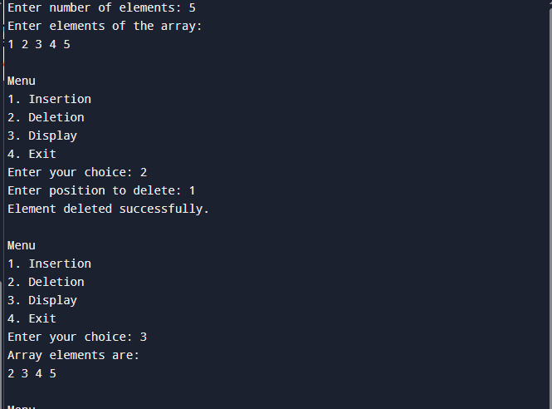

2.MATRICES OPERATIONS
#include <stdio.h>
int main() {
int n, sum, difference, transpose;
printf("Enter the number of dimension;\n");
scanf("%d", &n);
int a[n][n], b[n][n], c[n][n];

printf("Enter Matrix A:\n");
for(int i=0; i<n; i++){
for(int j=0; j<n; j++){
scanf("%d", &a[i][j]);
}
}

printf("Enter Matrix B:\n");
for(int i=0; i<n; i++){
for(int j=0; j<n; j++){
scanf("%d", &b[i][j]);
}
}

printf("Sum of A & B:\n");
for(int i=0; i<n; i++){
for(int j=0; j<n; j++){
sum = a[i][j] + b[i][j];
printf(" %d\t", sum);
}
printf("\n");
}

printf("Difference of A & B:\n");
for(int i=0; i<n; i++){
for(int j=0; j<n; j++){
difference = a[i][j] - b[i][j];
printf(" %d\t", difference);
}
printf("\n");
}

printf("Transpose of A :\n");
for(int i=0; i<n; i++){
for(int j=0; j<n; j++){
transpose = a[j][i];
printf(" %d\t", transpose);
}
printf("\n");
}

printf("Product of A & B :\n");
for(int i=0; i<n; i++){
for(int j=0; j<n; j++){
c[i][j] = 0;
}
}

for(int i=0; i<n; i++){
for(int j=0; j<n; j++){
for(int k=0; k<n; k++){
c[i][j]+=a[i][k]*b[k][j];
}
printf(" %d\t", c[i][j]);
}
printf("\n");
}
return 0;
}
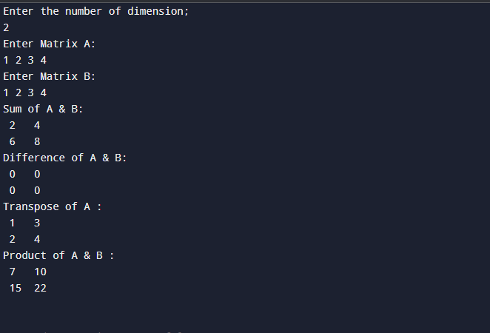

3.SORTING
#include <stdio.h>

#define MAX 100

void printArray(int arr[], int n) {
for (int i = 0; i < n; i++)
printf("%d ", arr[i]);
printf("\n");
}

void bubbleSort(int arr[], int n) {
for (int i = 0; i < n-1; i++) {
for (int j = 0; j < n-i-1; j++) {
if (arr[j] > arr[j+1]) {
int temp = arr[j];
arr[j] = arr[j+1];
arr[j+1] = temp;
}
}
}
}

void insertionSort(int arr[], int n) {
for (int i = 1; i < n; i++) {
int key = arr[i];
int j = i - 1;
while (j >= 0 && arr[j] > key) {
arr[j+1] = arr[j];
j--;
}
arr[j+1] = key;
}
}

int partition(int arr[], int low, int high) {
int pivot = arr[high];
int i = (low - 1);
for (int j = low; j < high; j++) {
if (arr[j] < pivot) {
i++;
int temp = arr[i]; arr[i] = arr[j]; arr[j] = temp;
}
}
int temp = arr[i+1]; arr[i+1] = arr[high]; arr[high] = temp;
return (i+1);
}

void quickSort(int arr[], int low, int high) {
if (low < high) {
int pi = partition(arr, low, high);
quickSort(arr, low, pi-1);
quickSort(arr, pi+1, high);
}
}

void merge(int arr[], int l, int m, int r) {
int n1 = m - l + 1, n2 = r - m;
int L[n1], R[n2];
for (int i = 0; i < n1; i++) L[i] = arr[l+i];
for (int j = 0; j < n2; j++) R[j] = arr[m+1+j];

int i=0, j=0, k=l;
while (i<n1 && j<n2) {
if (L[i] <= R[j]) arr[k++] = L[i++];
else arr[k++] = R[j++];
}
while (i<n1) arr[k++] = L[i++];
while (j<n2) arr[k++] = R[j++];
}

void mergeSort(int arr[], int l, int r) {
if (l < r) {
int m = l + (r-l)/2;
mergeSort(arr, l, m);
mergeSort(arr, m+1, r);
merge(arr, l, m, r);
}
}

void heapify(int arr[], int n, int i) {
int largest = i;
int l = 2*i+1, r = 2*i+2;
if (l < n && arr[l] > arr[largest]) largest = l;
if (r < n && arr[r] > arr[largest]) largest = r;
if (largest != i) {
int temp = arr[i]; arr[i] = arr[largest]; arr[largest] = temp;
heapify(arr, n, largest);
}
}

void heapSort(int arr[], int n) {
for (int i = n/2-1; i >= 0; i--)
heapify(arr, n, i);
for (int i = n-1; i > 0; i--) {
int temp = arr[0]; arr[0] = arr[i]; arr[i] = temp;
heapify(arr, i, 0);
}
}

int main() {
int arr[MAX], n, choice;
printf("Enter number of elements: ");
scanf("%d", &n);
printf("Enter elements: ");
for (int i = 0; i < n; i++) scanf("%d", &arr[i]);

printf("\nChoose Sorting Method:\n");
printf("1. Bubble Sort\n2. Insertion Sort\n3. Quick Sort\n4. Merge Sort\n5. Heap Sort\n");
scanf("%d", &choice);

switch(choice) {
case 1: bubbleSort(arr, n); break;
case 2: insertionSort(arr, n); break;
case 3: quickSort(arr, 0, n-1); break;
case 4: mergeSort(arr, 0, n-1); break;
case 5: heapSort(arr, n); break;
default: printf("Invalid choice!\n"); return 0;
}

printf("Sorted Array: ");
printArray(arr, n);
return 0;
}
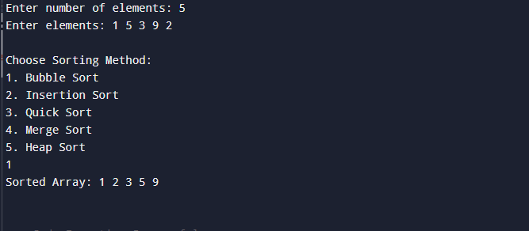

4.PROGRAM TO SEARCH THE ELEMENTS
#include <stdio.h>

int linearSearch(int arr[], int n, int key) {
int i;
for(i = 0; i < n; i++) {
if(arr[i] == key) {
return i;
}
}
return -1;
}

int binarySearch(int arr[], int n, int key) {
int low = 0, high = n - 1, mid;

while(low <= high) {
mid = (low + high) / 2;

if(arr[mid] == key)
return mid;
else if(arr[mid] < key)
low = mid + 1;
else
high = mid - 1;
}

return -1;
}

int main() {
int arr[100], n, key, i, result, choice;

printf("Enter number of elements: ");
scanf("%d", &n);

printf("Enter elements: ");
for(i = 0; i < n; i++) {
scanf("%d", &arr[i]);
}

printf("\n1. Linear Search\n");
printf("2. Binary Search\n");
printf("Enter your choice: ");
scanf("%d", &choice);

printf("Enter element to search: ");
scanf("%d", &key);

if(choice == 1) {
result = linearSearch(arr, n, key);
}
else if(choice == 2) {
result = binarySearch(arr, n, key);
}
else {
printf("Invalid choice");
return 0;
}

if(result == -1)
printf("Element not found.\n");
else
printf("Element found at position %d\n", result + 1);

return 0;
}
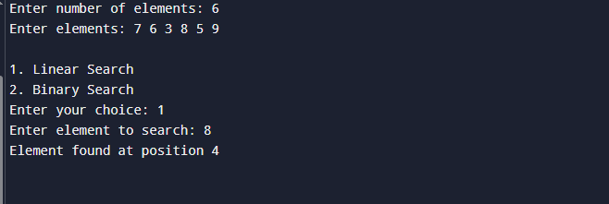

5.A program to perform all operations of stack, queue and circular queue using an array
#include <stdio.h>
#define MAX 5

int stack[MAX], top = -1;

void push() {
int val;
if (top == MAX - 1) {
printf("Stack Overflow\n");
} else {
printf("Enter value: ");
scanf("%d", &val);
stack[++top] = val;
}
}

void pop() {
if (top == -1) {
printf("Stack Underflow\n");
} else {
printf("Deleted: %d\n", stack[top--]);
}
}

void displayStack() {
if (top == -1) {
printf("Stack is empty\n");
} else {
for (int i = top; i >= 0; i--) {
printf("%d ", stack[i]);
}
printf("\n");
}
}

int queue[MAX], front = -1, rear = -1;

void enqueue() {
int val;
if (rear == MAX - 1) {
printf("Queue Overflow\n");
} else {
printf("Enter value: ");
scanf("%d", &val);
if (front == -1) front = 0;
queue[++rear] = val;
}
}

void dequeue() {
if (front == -1 || front > rear) {
printf("Queue Underflow\n");
} else {
printf("Deleted: %d\n", queue[front++]);
}
}

void displayQueue() {
if (front == -1 || front > rear) {
printf("Queue is empty\n");
} else {
for (int i = front; i <= rear; i++) {
printf("%d ", queue[i]);
}
printf("\n");
}
}

int cqueue[MAX], f = -1, r = -1;

void cenqueue() {
int val;
if ((r + 1) % MAX == f) {
printf("Circular Queue Overflow\n");
} else {
printf("Enter value: ");
scanf("%d", &val);
if (f == -1) f = 0;
r = (r + 1) % MAX;
cqueue[r] = val;
}
}

void cdequeue() {
if (f == -1) {
printf("Circular Queue Underflow\n");
} else {
printf("Deleted: %d\n", cqueue[f]);
if (f == r) {
f = r = -1;
} else {
f = (f + 1) % MAX;
}
}
}

void displayCQueue() {
if (f == -1) {
printf("Circular Queue is empty\n");
} else {
int i = f;
while (1) {
printf("%d ", cqueue[i]);
if (i == r) break;
i = (i + 1) % MAX;
}
printf("\n");
}
}

int main() {
int choice, ch;

do {
printf("\n--- MAIN MENU ---\n");
printf("1. Stack\n2. Queue\n3. Circular Queue\n4. Exit\n");
scanf("%d", &choice);

switch (choice) {

case 1:
do {
printf("\n--- STACK MENU ---\n");
printf("1. Push\n2. Pop\n3. Display\n4. Back\n");
scanf("%d", &ch);

switch (ch) {
case 1: push(); break;
case 2: pop(); break;
case 3: displayStack(); break;
}
} while (ch != 4);
break;

case 2:
do {
printf("\n--- QUEUE MENU ---\n");
printf("1. Enqueue\n2. Dequeue\n3. Display\n4. Back\n");
scanf("%d", &ch);

switch (ch) {
case 1: enqueue(); break;
case 2: dequeue(); break;
case 3: displayQueue(); break;
}
} while (ch != 4);
break;

case 3:
do {
printf("\n--- CIRCULAR QUEUE MENU ---\n");
printf("1. Enqueue\n2. Dequeue\n3. Display\n4. Back\n");
scanf("%d", &ch);

switch (ch) {
case 1: cenqueue(); break;
case 2: cdequeue(); break;
case 3: displayCQueue(); break;
}
} while (ch != 4);
break;

}

} while (choice != 4);

return 0;
}

Output for stack
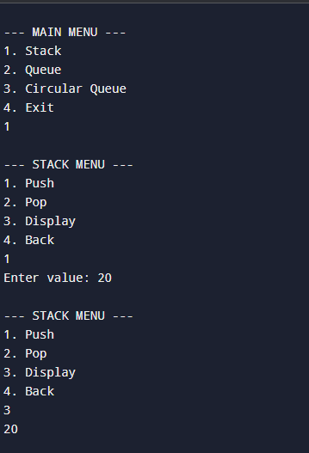
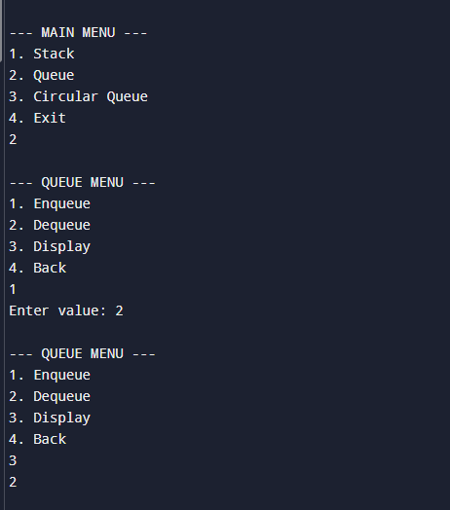

6. Write a program to evaluate the Postfix Notation
#include <stdio.h>

#define MAX 100

int stack[MAX];
int top = -1;

void push(int value) {
if (top == MAX - 1) {
printf("Stack overflow!\n");
return;
}
stack[++top] = value;
}

int pop() {
if (top == -1) {
printf("Stack underflow!\n");
return -1;
}
return stack[top--];
}

int evaluatePostfix(char* exp) {
int i;
for (i = 0; exp[i] != '\0'; i++) {

if (exp[i] >= '0' && exp[i] <= '9') {
push(exp[i] - '0');
}
else {

int val2 = pop();
int val1 = pop();
switch (exp[i]) {
case '+': push(val1 + val2); break;
case '-': push(val1 - val2); break;
case '*': push(val1 * val2); break;
case '/': push(val1 / val2); break;
default:
printf("Invalid operator: %c\n", exp[i]);
return -1;
}
}
}
return pop();
}

int main() {
char exp[MAX];
printf("Enter postfix expression (single-digit operands): ");
scanf("%s", exp);

int result = evaluatePostfix(exp);
printf("Result of postfix evaluation: %d\n", result);

return 0;
}
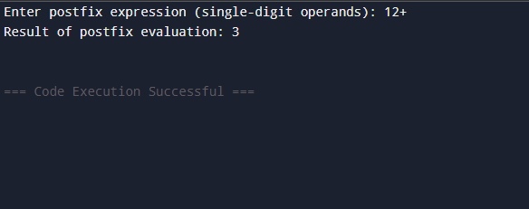
7. Write a program to convert infix notation into Postfix Notation.
#include <stdio.h>

#define MAX 100

char stack[MAX];
int top = -1;

void push(char c) {
if (top == MAX - 1) {
printf("Stack overflow!\n");
return;
}
stack[++top] = c;
}

char pop() {
if (top == -1) {
return -1;
}
return stack[top--];
}

char peek() {
if (top == -1) return -1;
return stack[top];
}

int precedence(char op) {
if (op == '^') return 3;
if (op == '*' || op == '/') return 2;
if (op == '+' || op == '-') return 1;
return 0;
}

int isOperator(char c) {
return (c == '+' || c == '-' || c == '*' || c == '/' || c == '^');
}

void infixToPostfix(char* infix) {
char postfix[MAX];
int i, k = 0;

for (i = 0; infix[i] != '\0'; i++) {
char c = infix[i];

if ((c >= 'A' && c <= 'Z') || (c >= 'a' && c <= 'z') || (c >= '0' && c <= '9')) {
postfix[k++] = c;
}

else if (c == '(') {
push(c);
}

else if (c == ')') {
while (top != -1 && peek() != '(') {
postfix[k++] = pop();
}
pop();
}

else if (isOperator(c)) {
while (top != -1 && precedence(peek()) >= precedence(c)) {
postfix[k++] = pop();
}
push(c);
}
}

while (top != -1) {
postfix[k++] = pop();
}

postfix[k] = '\0';
printf("Postfix Expression: %s\n", postfix);
}

int main() {
char infix[MAX];
printf("Enter infix expression: ");
scanf("%s", infix);

infixToPostfix(infix);

return 0;
}
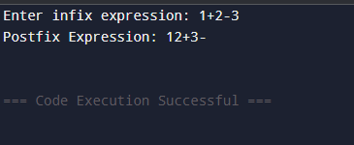
- Write a program to perform the operations of the linked list:
  - Insertion
  - Deletion
  - Display

#include <stdio.h>
#include <stdlib.h>

struct Node {
int data;
struct Node* next;
};

struct Node* head = NULL;

void insert(int value) {
struct Node* newNode = (struct Node*)malloc(sizeof(struct Node));
newNode->data = value;
newNode->next = NULL;

if (head == NULL) {
head = newNode;
} else {
struct Node* temp = head;
while (temp->next != NULL) {
temp = temp->next;
}
temp->next = newNode;
}
printf("Node inserted successfully.\n");
}

void deleteNode(int value) {
struct Node *temp = head, *prev = NULL;

if (temp != NULL && temp->data == value) {
head = temp->next;
free(temp);
printf("Node deleted successfully.\n");
return;
}

while (temp != NULL && temp->data != value) {
prev = temp;
temp = temp->next;
}

if (temp == NULL) {
printf("Value not found in list.\n");
return;
}

prev->next = temp->next;
free(temp);
printf("Node deleted successfully.\n");
}

void display() {
struct Node* temp = head;

if (temp == NULL) {
printf("List is empty.\n");
return;
}

printf("Linked List: ");
while (temp != NULL) {
printf("%d -> ", temp->data);
temp = temp->next;
}
printf("NULL\n");
}

int main() {
int choice, value;

while (1) {
printf("\n--- Linked List Menu ---\n");
printf("1. Insert\n");
printf("2. Delete\n");
printf("3. Display\n");
printf("4. Exit\n");
printf("Enter your choice: ");
scanf("%d", &choice);

switch (choice) {
case 1:
printf("Enter value to insert: ");
scanf("%d", &value);
insert(value);
break;

case 2:
printf("Enter value to delete: ");
scanf("%d", &value);
deleteNode(value);
break;

case 3:
display();
break;

case 4:
exit(0);

default:
printf("Invalid choice!\n");
}
}

return 0;
}
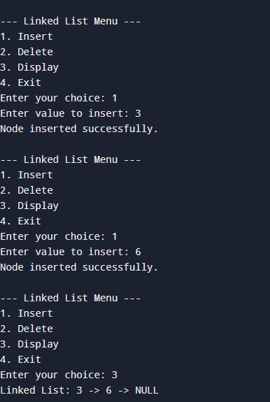

- Write a program to perform the operations of the Circular linked list:
    - Insertion
    - Deletion
    - Display

#include <stdio.h>
#include <stdlib.h>

struct Node {
int data;
struct Node *next;
};

struct Node *head = NULL;

void insert(int value) {
struct Node *newNode, *temp;
newNode = (struct Node*)malloc(sizeof(struct Node));
newNode->data = value;

if (head == NULL) {
head = newNode;
newNode->next = head;
}
else {
temp = head;
while (temp->next != head) {
temp = temp->next;
}
temp->next = newNode;
newNode->next = head;
}

printf("Node inserted successfully.\n");
}

void deleteNode(int value) {
struct Node *temp = head, *prev;

if (head == NULL) {
printf("List is empty.\n");
return;
}

if (head->data == value) {
while (temp->next != head)
temp = temp->next;

if (temp == head) {
free(head);
head = NULL;
} else {
temp->next = head->next;
free(head);
head = temp->next;
}
printf("Node deleted successfully.\n");
return;
}

prev = head;
temp = head->next;

while (temp != head) {
if (temp->data == value) {
prev->next = temp->next;
free(temp);
printf("Node deleted successfully.\n");
return;
}
prev = temp;
temp = temp->next;
}

printf("Value not found in list.\n");
}

void display() {
struct Node *temp = head;

if (head == NULL) {
printf("List is empty.\n");
return;
}

printf("Circular Linked List: ");
do {
printf("%d -> ", temp->data);
temp = temp->next;
} while (temp != head);

printf("(Back to Head)\n");
}

int main() {
int choice, value;

while (1) {
printf("\n--- Circular Linked List Menu ---\n");
printf("1. Insert\n");
printf("2. Delete\n");
printf("3. Display\n");
printf("4. Exit\n");
printf("Enter choice: ");
scanf("%d", &choice);

switch (choice) {
case 1:
printf("Enter value to insert: ");
scanf("%d", &value);
insert(value);
break;

case 2:
printf("Enter value to delete: ");
scanf("%d", &value);
deleteNode(value);
break;

case 3:
display();
break;

case 4:
exit(0);

default:
printf("Invalid choice!\n");
}
}

return 0;
}
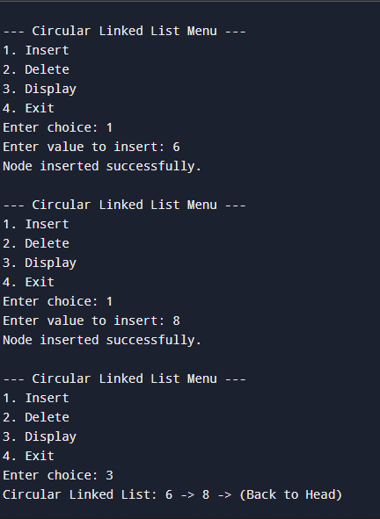
- Write a program to perform all operations:
  - For Stack using Linked List
  - For Queue using Linked List
  - For Circular Queue using Linked List

#include <stdio.h>
#include <stdlib.h>

struct node {
int data;
struct node* next;
};

struct node* top = NULL;

void push(int val) {
struct node* temp = (struct node*)malloc(sizeof(struct node));
temp->data = val;
temp->next = top;
top = temp;
}

void pop() {
if (top == NULL) {
printf("Stack Underflow\n");
return;
}
struct node* temp = top;
printf("Popped: %d\n", temp->data);
top = top->next;
free(temp);
}

void displayStack() {
struct node* temp = top;
while (temp != NULL) {
printf("%d ", temp->data);
temp = temp->next;
}
printf("\n");
}

struct node* front = NULL;
struct node* rear = NULL;

void enqueue(int val) {
struct node* temp = (struct node*)malloc(sizeof(struct node));
temp->data = val;
temp->next = NULL;

if (rear == NULL) {
front = rear = temp;
} else {
rear->next = temp;
rear = temp;
}
}

void dequeue() {
if (front == NULL) {
printf("Queue Underflow\n");
return;
}
struct node* temp = front;
printf("Dequeued: %d\n", temp->data);
front = front->next;

if (front == NULL) rear = NULL;
free(temp);
}

void displayQueue() {
struct node* temp = front;
while (temp != NULL) {
printf("%d ", temp->data);
temp = temp->next;
}
printf("\n");
}

struct node* cfront = NULL;
struct node* crear = NULL;

void cenqueue(int val) {
struct node* temp = (struct node*)malloc(sizeof(struct node));
temp->data = val;

if (cfront == NULL) {
cfront = crear = temp;
temp->next = cfront;
} else {
crear->next = temp;
crear = temp;
crear->next = cfront;
}
}

void cdequeue() {
if (cfront == NULL) {
printf("Circular Queue Underflow\n");
return;
}

struct node* temp = cfront;
printf("Deleted from Circular Queue: %d\n", temp->data);

if (cfront == crear) {
cfront = crear = NULL;
} else {
cfront = cfront->next;
crear->next = cfront;
}
free(temp);
}

void displayCQueue() {
if (cfront == NULL) return;

struct node* temp = cfront;
do {
printf("%d ", temp->data);
temp = temp->next;
} while (temp != cfront);
printf("\n");
}

int main() {

printf("\n--- STACK OPERATIONS ---\n");
push(10);
push(20);
push(30);
displayStack();
pop();
displayStack();

printf("\n--- QUEUE OPERATIONS ---\n");
enqueue(1);
enqueue(2);
enqueue(3);
displayQueue();
dequeue();
displayQueue();

printf("\n--- CIRCULAR QUEUE OPERATIONS ---\n");
cenqueue(5);
cenqueue(6);
cenqueue(7);
displayCQueue();
cdequeue();
displayCQueue();

return 0;
}
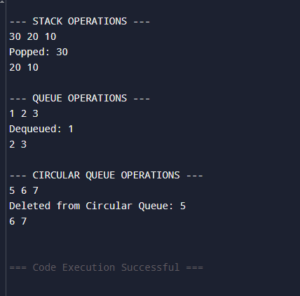

- Write a program to perform concatenation of two linked lists.

#include <stdio.h>
#include <stdlib.h>

struct Node {
int data;
struct Node* next;
};

void insert(struct Node** head, int value) {
struct Node* newNode = (struct Node*)malloc(sizeof(struct Node));
newNode->data = value;
newNode->next = NULL;

if(*head == NULL) {
*head = newNode;
} else {
struct Node* temp = *head;
while(temp->next != NULL)
temp = temp->next;
temp->next = newNode;
}
}

void display(struct Node* head) {
if(head == NULL) {
printf("List is empty\n");
return;
}
struct Node* temp = head;
while(temp != NULL) {
printf("%d ", temp->data);
temp = temp->next;
}
printf("\n");
}

void concatenate(struct Node** head1, struct Node* head2) {
if(*head1 == NULL) {
*head1 = head2;
return;
}
struct Node* temp = *head1;
while(temp->next != NULL)
temp = temp->next;
temp->next = head2;
}

int main() {
struct Node* list1 = NULL;
struct Node* list2 = NULL;

insert(&list1, 10);
insert(&list1, 20);
insert(&list1, 30);

insert(&list2, 40);
insert(&list2, 50);
insert(&list2, 60);

printf("List 1: ");
display(list1);

printf("List 2: ");
display(list2);

concatenate(&list1, list2);

printf("After concatenation: ");
display(list1);

return 0;
}
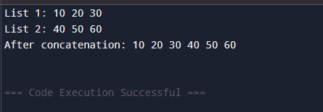

- Write a program to perform the operations of the Double linked list:
  - Insertion
  - Deletion
  - Display

#include <stdio.h>
#include <stdlib.h>

struct Node {
int data;
struct Node* next;
struct Node* prev;
};

void insert(struct Node** head, int value) {
struct Node* newNode = (struct Node*)malloc(sizeof(struct Node));
newNode->data = value;
newNode->next = newNode->prev = NULL;

if(*head == NULL) {
*head = newNode;
} else {
struct Node* temp = *head;
while(temp->next != NULL)
temp = temp->next;
temp->next = newNode;
newNode->prev = temp;
}
}

void deleteNode(struct Node** head, int value) {
if(*head == NULL) {
printf("List is empty\n");
return;
}

struct Node* temp = *head;
if(temp->data == value) {
*head = temp->next;
if(*head != NULL) (*head)->prev = NULL;
free(temp);
return;
}
while(temp != NULL && temp->data != value)
temp = temp->next;

if(temp == NULL) {
printf("Value %d not found\n", value);
return;
}

temp->prev->next = temp->next;
if(temp->next != NULL)
temp->next->prev = temp->prev;

free(temp);
}

void display(struct Node* head) {
if(head == NULL) {
printf("List is empty\n");
return;
}

printf("Doubly Linked List: ");
struct Node* temp = head;
while(temp != NULL) {
printf("%d ", temp->data);
temp = temp->next;
}
printf("\n");
}

int main() {
struct Node* head = NULL;
insert(&head, 10);
insert(&head, 20);
insert(&head, 30);

printf("After insertion:\n");
display(head);

deleteNode(&head, 20);
printf("After deleting 20:\n");
display(head);

deleteNode(&head, 40);

return 0;
}
